**Sculpture**

A form of three-dimensional art made by carving, modeling, casting, and constructing.

Painting versus Sculpture

Painting is two-dimensional; it is flat and you do not have to worry about weight.

Sculpture is three-dimensional; it has weight and requires engineering skills to transfer that weight back to the ground.

Sculptures all deal with dimensionality. This seen in many different ways:

* In the round – standing free with all sides shown, rather than carved in relief against a ground. A view is able to walk completely around the sculpture and can see detail on all sides.

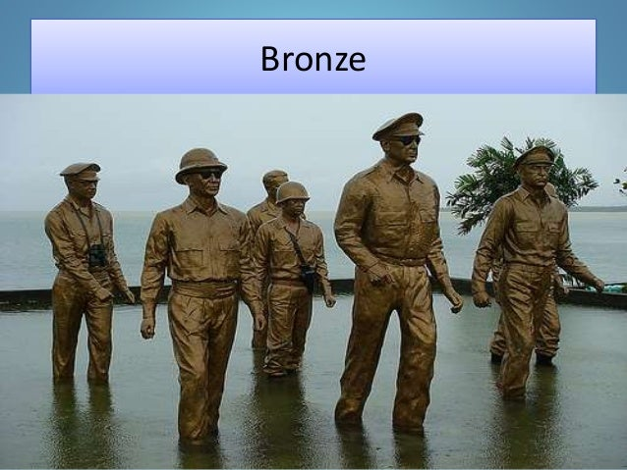

* High Relief (Partially Full Round) - the forms project at least half or more of their natural circumference from the background and may in parts be completely disengaged from the ground, thus approximating sculpture in the round.

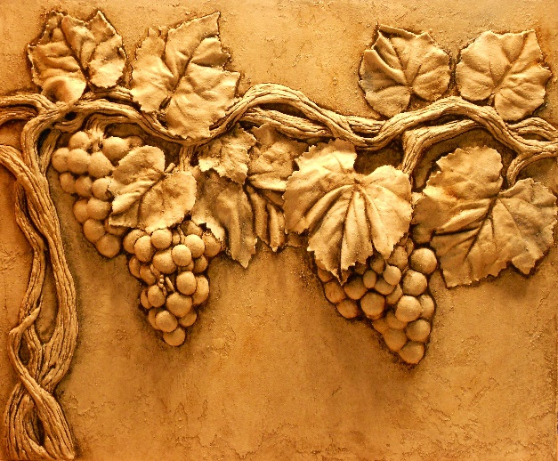

* 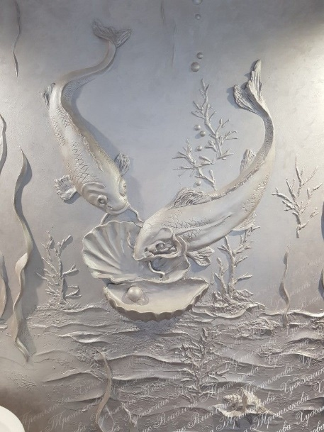Low Relief - A **low** bas-**relief sculpture** refers to a carving crafted in such a manner that the artwork is barely protruding from the background piece.
* 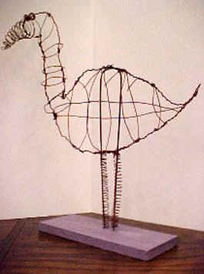Linear Sculpture - a line is most often is the place where two (or more) planes intersect. By depicting or creating lines, one can suggest the presence of one or more planes.

There are many different executions that can be used in order to create a sculpture. These executions are how you manipulate the materials you are working with.

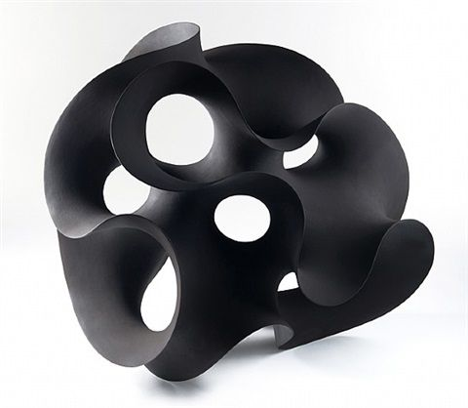Subtraction is the technique of removing material to create a finished work of art.

* Subtraction can be cutting, scoring, or carving of the material.

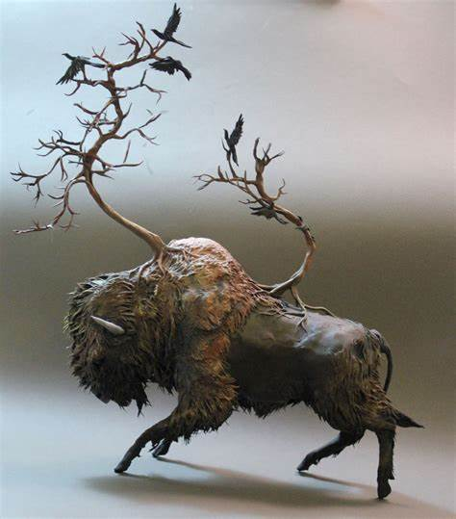Additive – the process of creating a sculpture by adding material to create a work of art. You start with one main piece and then add more parts to it.

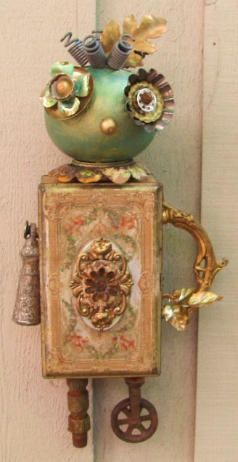Construction – This type of sculpture is made from scraps, junk, and odds and ends (as of paper, cloth, wood, stone, or metal) the art of making assemblages. Construction sculptures will use more than one material that is recycled/upcycled.

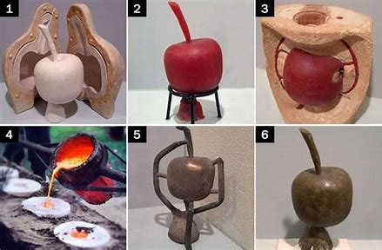Substitution - a technique utilizing materials transformed from a plastic, molten, or fluid into a solid state.

Manipulation - The user can create, shape and manipulate sculptures, carved or modeled forms of art in three dimensions and made with earthen materials such as stone and clay as well as wood. Items such as pottery or wax carving would be an example of manipulation.

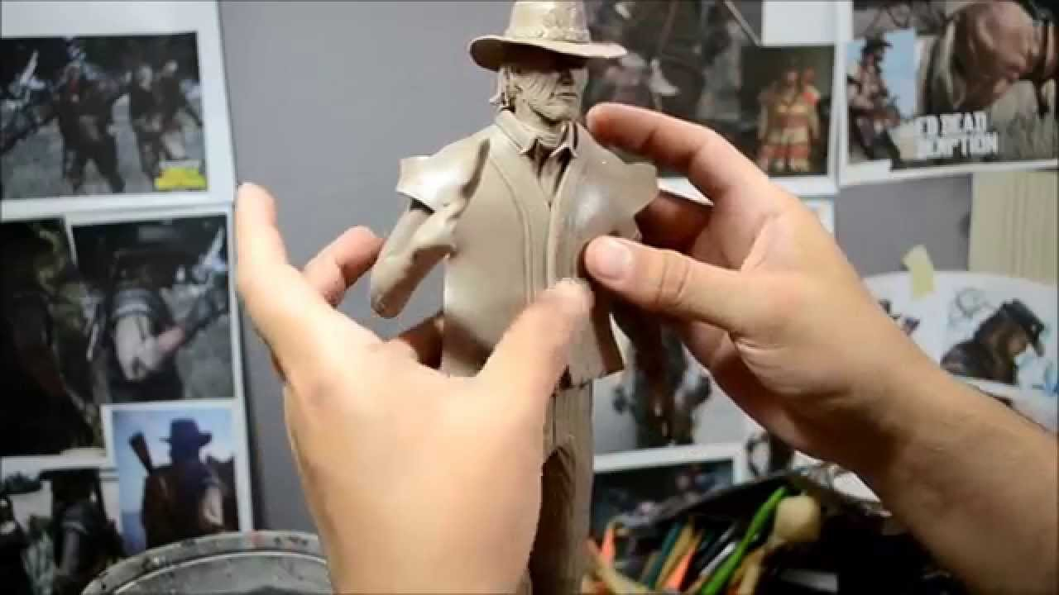

Composition – Shares the same elements and principles that are in two-dimensional art. These include mass, form, line, space, color, texture, proportion, and movement.

* + Mass – actual weight and form of the sculpture.
  + Line/Form – This is the idea that line will help to show/demonstrate the edges of the objects.
  + Color – this comes from the actual material used. A sculpture can also be painted.
  + Texture – this helps to show emotion and movement. It helps to add emotion to the piece of art by catching the light.
  + Proportion – Refers to the dimensions of a composition and relationships between height, width, and depth. How proportions are used will affect how realistic or stylized and artwork is.
  + Articulation/ Eye Movement – this refers to how the eye moves from one element to the next within a sculpture, painting or photograph.
  + Focal Area – the area of the composition to which the viewers’ eye is naturally drawn. Movement generally begins at the focal area first.
  + Center of Mass – this is the largest area of a subject. If it is clearly, a human it will be the face and then the eye will move on from there.

Sculptures and art in general, is categorized by some of the different materials that are being used as well as why/meaning behind the artwork itself:

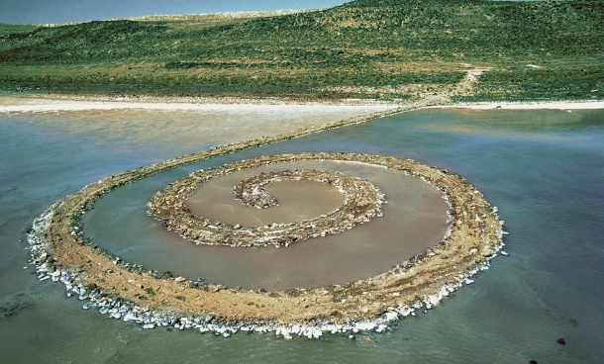 Ephemeral Art – Art that only lasts for a short amount of time.

* It creates a pure form and is meant to be temporary
* Used as a protest against the idea of an art gallery or museum/Organized display’s
* The concept of ephemeral art would also include the various forms of so-called action art, such as happening, performance, environment and installation, or conceptual art, such as body art and land art, as well as other expressions of popular culture, such as graffiti.

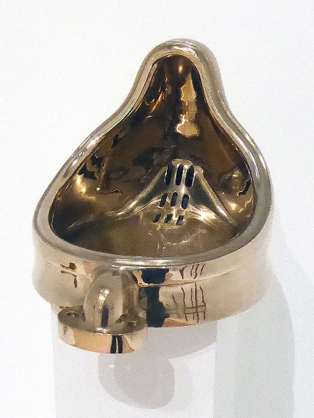 Found Art – created from undisguised, but often modified objects or products are not considered materials from which art is made; often because they already have a non-art function.

* This movement confronted not only traditional ideas about what art is, but also gave renewed life to objects that were the product of mass production, and questioned consumerism – which were both ideas that were emerging at the time in response to the industrial revolution.

***Sense Stimuli*** are parts of a sculpture that can actually be touched. Touch within the sculpture gives us the feeling that it is soft rather than hard like marble. Each material will lend itself to a certain texture or feel, when we change the material being used the texture will also change and add interest.

***Temperature*** – Warm and cool tones will affect how we assume something would actually feel.

***Age*** – Weather gives a sculpture the idea of how old something is. It makes us think about the time period it was created. Age will also affect how we interpret it.

***Dynamic vs. Static***

Dynamic shows movement or is actually moving.

Static shows how something is not moving at all; very stable with no movement.

***Size*** – The actual size matters in a sculpture because it shows importance.

There are less details shown in large sculptures.

***Environment*** – The area where a sculpture is made or placed provides context for the sculpture we are viewing. The context is important.